UT members adding new dependents to coverage will be required to upload documentation electronically in My UT Benefits. For coverage to be retained for the dependent, the uploaded documentation must be approved or granted an exception by the UT member’s benefits office. The Office of Employee Benefits (OEB) has created this document to explain the entire documentation process, answer questions, and facilitate the continued improvement of the system. This process is often referred to as “Evidence of Eligibility (EOE),” not to be confused with “Evidence of Insurability (EOI).”

My UT Benefits (MyUTB):

Dependents are now listed on a dedicated tab with My UT Benefits:

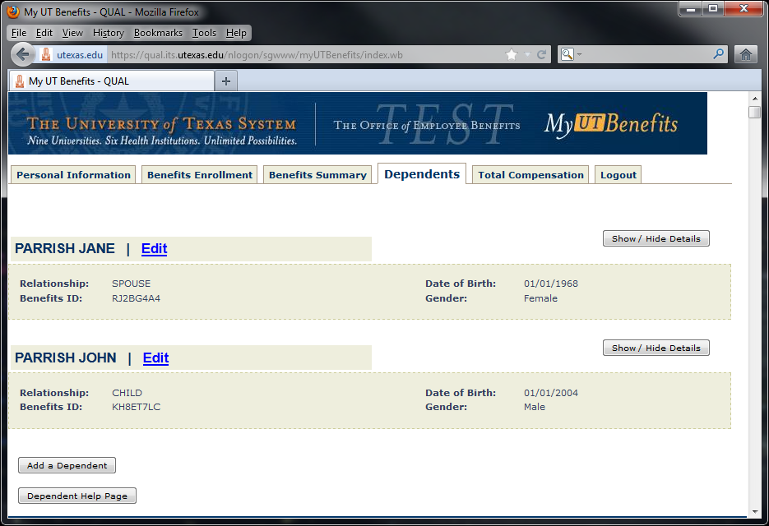

Dependents can be removed and information can be updated by clicking the Edit link. Dependent Detail Information can be displayed by clicking the Show / Hide Details button. New dependents can be added by clicking the Add a Dependent button.
Help on all dependent-related actions is found by clicking the Dependent Help Page button.

When a new dependent is added and given coverage, documentation requirements will be issued and displayed automatically in the dependent details section. Also, a banner at the top of the page will indicate that documentation is required:
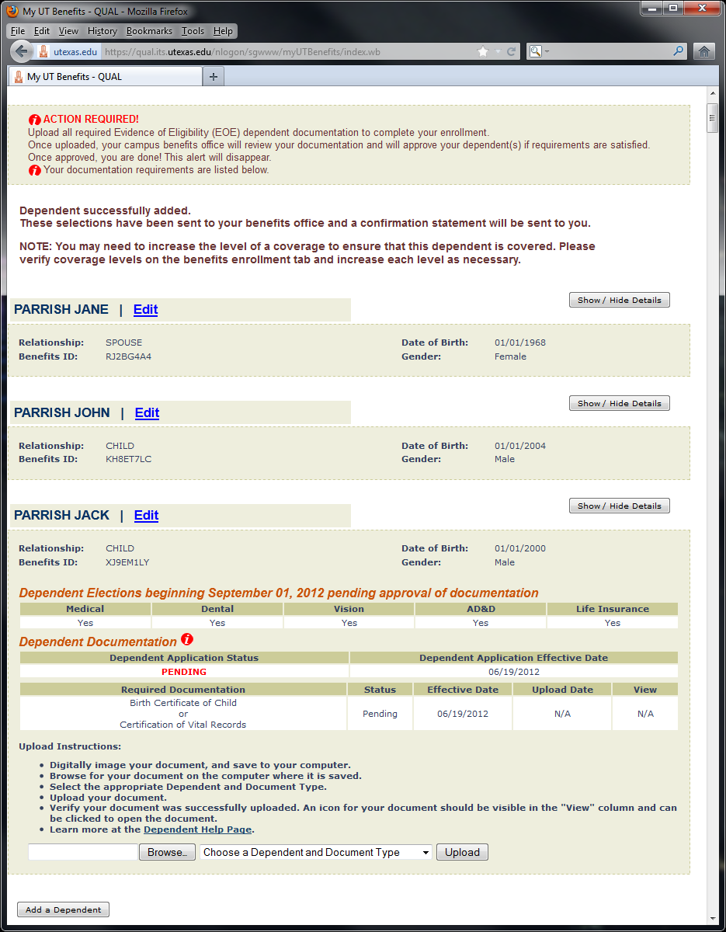

Above, a child (Jack Parrish) was added. A banner at the top of the page indicates that dependent documentation is required (the banner is displayed on ALL MyUTB tabs). The dependent detail section for the child is open, and lists three sections:

- Dependent Elections
- Dependent Documentation
- Documentation Upload and Instructions

- Dependent coverage elections (table #1) are listed pending approval or exception of required documentation. Dependent coverage will be reversed (rolled back) on or around August 20th if the dependent is not approved or excepted.

- The Dependent Documentation section displays:

  - The dependent status and effective date (table #2)
  - The documentation requirements, status, effective date, upload date, and view (table #3)

By far, the most important item is the dependent status. This status will indicate whether a dependent will be able to retain coverage (“Approved” or “Exception”) or will have coverage reversed (any status other than “Approved” or “Exception”). All dependents are initially in a “Pending” status.

The dependent effective date is the effective date of the most recent status change.

One row will be displayed for each document required. If two documents are required for a dependent type, then two rows would be displayed…one for each document type. If the member can satisfy a document requirement by uploading one of many options, then those options would all be displayed on one row. In the example above, one document is required for a child…either a Birth Certificate or a Certification of Vital Records. Either can be uploaded.

The documentation status lists the most recent status of the documentation uploaded. All documentation is initially in a “Pending” status.

The documentation effective date is the effective date of the most recent documentation status.

If documentation has been uploaded, the documentation upload date would display the date on which documentation was uploaded.

If documentation has been uploaded, an icon would appear in the View column. Clicking the icon will open the uploaded documentation for review.

- The Documentation Upload and Instructions section provides help on how to upload a document and links to the Dependent Help Page for additional dependent-related questions. In addition to browsing to and selecting the document to upload, the member must provide the appropriate Dependent / Document Type:
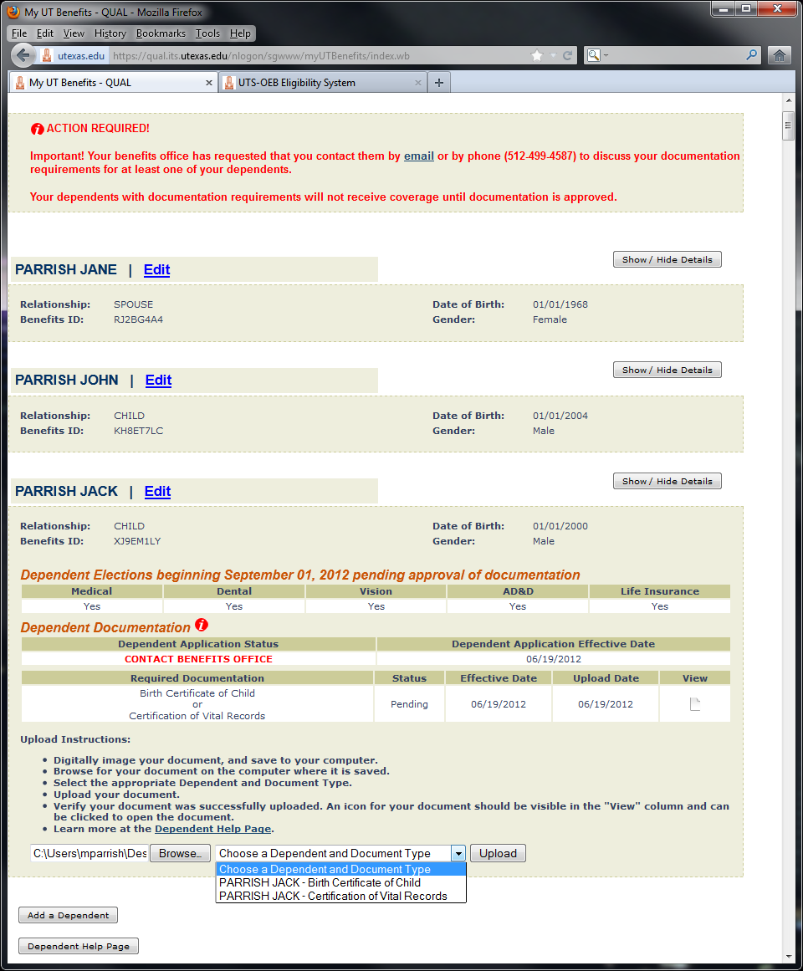

After upload, a success message will be displayed. Also, a document icon will appear under “View” and a document upload date of today will be displayed. The document icon can be clicked to view the document:

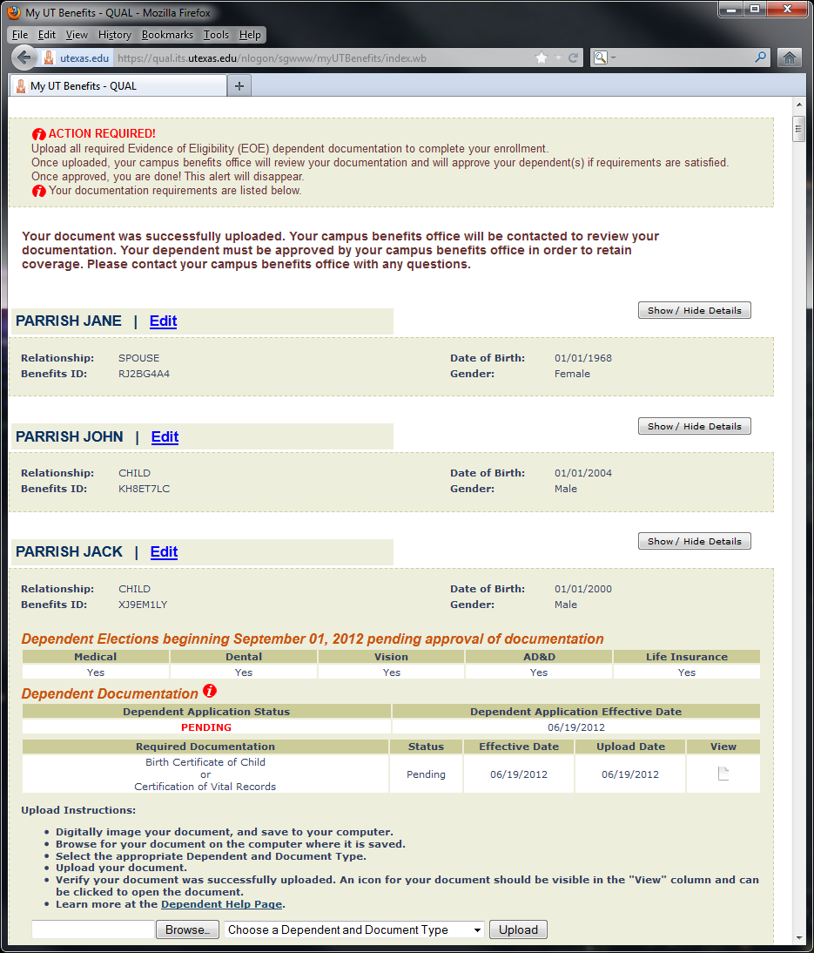

Campus Email Notification:

Every evening during Annual Enrollment, OEB will identify all “Pending” dependents with uploaded documentation. An email will be sent to your campus benefits office which lists the total number of “pending with uploaded” dependents and their type. A link to SGELIG is provided as well, so that the documentation for these dependents can be reviewed and worked in the new Document Tracking section of SGELIG. A sample email is below:

SUBJECT: UTSADMIN -- Dependent Documentation Review

TO: PARRISH, MARC mparrish@utsystem.edu

Attention UTSADMIN :

Members at UTSADMIN have uploaded documentation for dependents that requires your review. Please connect to SGELIG to review and work the uploaded documentation.

Unapproved dependents with required documentation will have all coverage elections reversed on August 15, 2012 if no action is taken. To ensure coverage reversal does not take place, a dependent must either be approved or granted an exception.

Dependents to be Reviewed:

TOTAL DEPENDENTS: 5

CHILD : 4
ADOPTED CHILD: 1

Review dependent documentation in SGELIG:

https://utdirect.utexas.edu/sgelig/

CONTROL=JOB:SGNWLNEE;STEP:SGPBLNEE;LIBR:SGLTEQ;PRGM:SGPBLNEE;USER:SGMHP.

SGELIG Document Tracking

The Document Tracking section of SGELIG can be accessed by:

- Clicking “Document Tracking” in the SGELIG menu
- Clicking the “Track Dependents” link

On first entry, Document Tracking will only display dependents in a “Pending” status with uploaded documentation. This group, after all, is the priority. These are the dependents for whom potentially acceptable documentation has been provided, but who have not yet been approved by your campus:

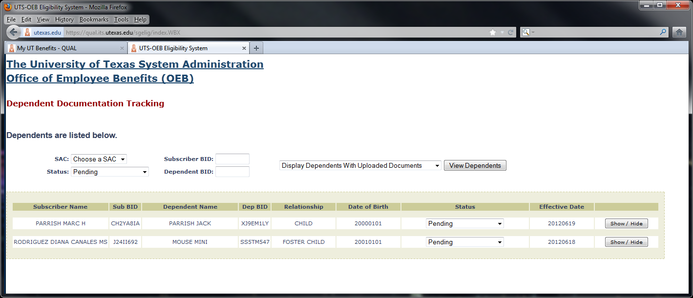

Document Tracking also allows for searches by state agency code (SAC) provided you are authorized for more than one campus, by dependent status, by subscriber ID, by dependent ID, and by documentation (uploaded, not uploaded, either). Choose your search criteria and click “View Dependents”.

Each dependent displays a Show / Hide button. Clicking this button displays and hides the dependent’s documentation information:

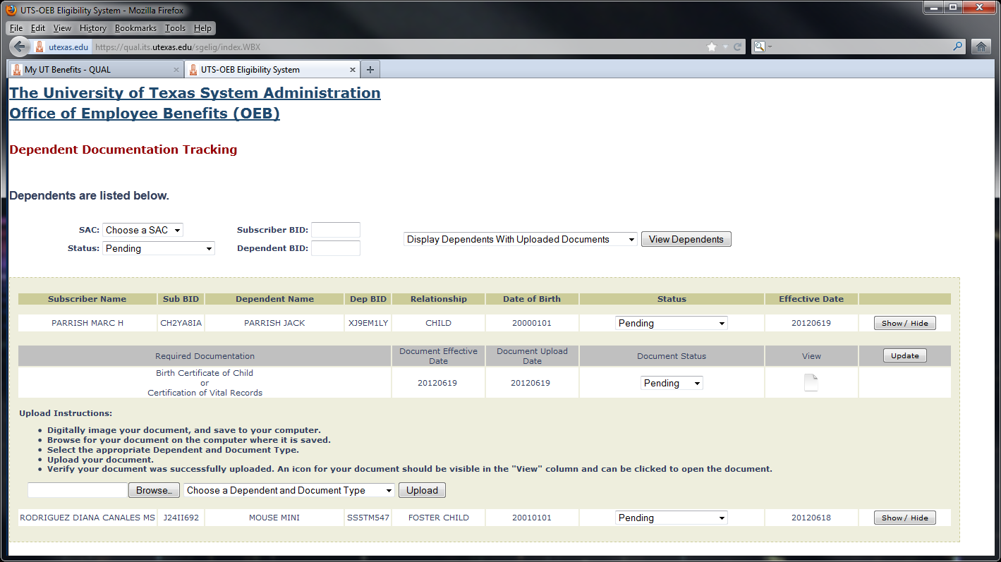

In the example above, Jack Parrish has a dependent status of “Pending.” Jack has one documentation requirement, which is also in a “Pending” status. Jack uploaded a document on 20120619, and this document can be reviewed by clicking the document icon under “View.”

Documentation can also be uploaded directly from this screen using the Documentation Upload and Instructions section seen earlier in My UT Benefits. It is likely that at least a few members will need assistance from campus benefits staff with the imaging and uploading of documentation. To facilitate this, the upload process was placed in SGELIG as well.

After review of documentation, campus benefits staff should update both the dependent and documentation statuses and click the “Update” button. As a reminder, it is the dependent status which is by far the most important, as this status will decide whether or not a dependent will retain coverage (“Approved” or “Exception”) or will have coverage reversed (any status other than “Approved” or “Exception”).

At the time of this writing, documentation does not need to be uploaded or resolved for a dependent to be approved / granted an exception. The system grants the campus the flexibility to approve / grant an exception as needed first and upload documentation later. As the documentation deadline approaches, there may be a large number of dependents with required documentation who should be approved as soon as possible………..and whose documentation can be imaged and uploaded after the deadline.

Confirmation Statements:

In addition to My UT Benefits, a member with documentation requirements will also be notified via the Confirmation statement:

IMPORTANT INFORMATION CONCERNING YOUR COVERAGE:
Documentation required for at least one of your dependents.
Connect to My UT Benefits for more information.

MARC PARRISH (AB1CD2EF) June 15, 2012

Re: Confirmation of Current Insurance Coverage Selections

. . . . . . . . . . . .

-----------------------------------------------------------------------------
Your dependent elections beginning September 01, 2012 are listed below.
If the information is not correct, please notify your benefits office.

Name Relationship DOB Med Den Vis AD&D LF

JANE PARRISH SPOUSE 01/01/68 YES YES NO YES NO
JOHN PARRISH CHILD 01/01/04 YES YES NO YES NO
JACK PARRISH CHILD* 01/01/00 YES YES NO YES NO
Dependent Application Pending on 06/13/12

* -- Documentation required for this dependent in My UT Benefits.
Connect to My UT Benefits for more information.

A banner is placed at the top to alert the member. The dependent with documentation requirements is marked in the dependent section, and the dependent status and effective date are displayed. The member is encouraged to connect to My UT Benefits.

“Contact Benefits Office”:

Every time the dependent status (not the document status!) is updated in SGELIG, the member will be marked to receive a confirmation statement overnight. The confirmation statement will display the new dependent status and effective date. If all dependents with documentation requirements for a member are “Approved” or granted an “Exception,” then the banner at the top of the letter would not be displayed. Once a dependent is “Approved” or granted an “Exception,” then the ability to upload a document for that dependent will be turned off in My UT Benefits.

It is anticipated that some members will unfortunately upload documentation that does not satisfy requirements. In many of these instances, there will be little choice but to reach out to the member. While future ideas for improving communication are encouraged, reaching out to membership for AE 2012 will be accomplished using the following procedure:

In SGELIG, set the dependent status to “Contact Benefits Office” and click “Update”:

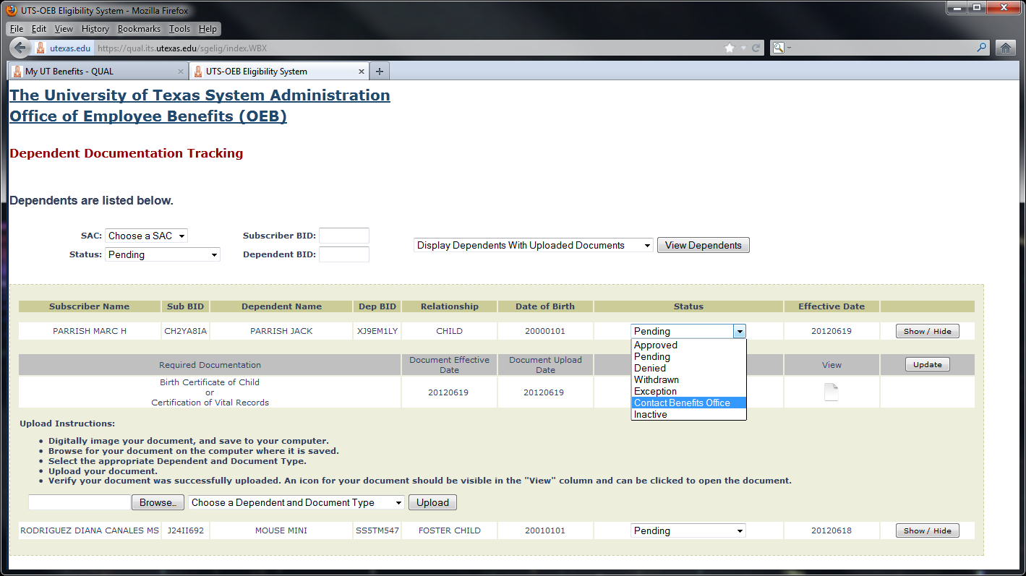

Selecting this particular status will do the following in My UT Benefits:

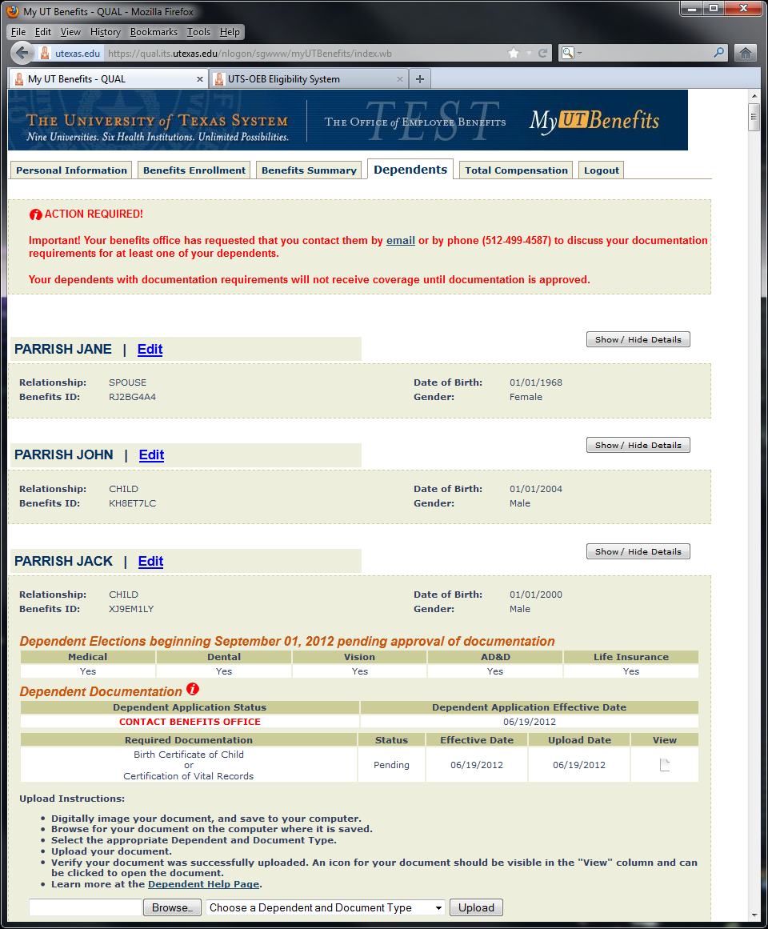

A confirmation statement will also be sent and will display the following banner:

IMPORTANT INFORMATION CONCERNING YOUR COVERAGE:
Documentation required for at least one of your dependents.
Connect to My UT Benefits for more information.
-----------------------------------------------------------------------------
** S P E C I A L N O T I C E **
-----------------------------------------------------------------------------
** Important! Your benefits office has requested that you contact them in
** order to discuss documentation requirements for at least one of your
** dependents. Your dependents with documentation requirements will not
** receive coverage until documentation is approved. You may contact your
** benefits office by phone or by replying to this email. Thank you.

. . . . . . . . .

EOE Reminder Email:

Unless your campus has requested otherwise, the deadline for uploading documentation is 11:59 p.m. on August 15th. On or around August 8th, an “EOE Reminder” email will be sent to all members who have a dependent with documentation requirements but have yet to upload documentation. The email will look like this:

SUBJECT: Your Outstanding Evidence of Eligibility (EOE)
Important Information Concerning Your Coverage!
This notification contains information about your ourstanding Evidence of
Eligibility (EOE) application(s).

IGOR D GREGORIC June 19, 2012

This notification has been sent as a reminder that you still have EOE
outstanding. At least one of your dependents requires approval of EOE before
dependent coverage elections can take effect. As of the date of this
notification, you have not yet uploaded required EOE documentation in My UT
Benefits.

If you still wish for your dependent coverage elections requiring approved EOE to take effect, please connect to My UT Benefits to upload your required
documentation by the deadline listed below. Your PIN is needed to connect to My UT Benefits, and may be obtained using the "Forgot PIN / Change PIN" feature in My UT Benefits.

If you no longer wish for your dependent coverage elections requiring EOE to
take effect, no action is needed on your part. Your elections requiring EOE
will be reversed before September 1. If you have any questions, please contact your benefits office.

Evidence of Eligibility documentation required by 08/15/12 for:

PARRISH JACK

My UT Benefits : https://utdirect.utexas.edu/nlogon/sgwww/myUTBenefits/

CONTROL=1NV IG0000087735COLIGOR*D*GREGORIC@UTH*TMC*EDU.

EOE Rollback / Reversal of Coverage:

The EOE rollback will occur on or around August 20th, unless your campus has requested otherwise. Dependents who have not been approved or excepted will have their coverage reversed. Subscribers of reversed dependents will be notified via EOE rollback letters. A special notice will be placed in the letter (language to come) indicating that coverage has been reversed because of a failure to meet EOE documentation requirements.

Approvals / Exceptions:

Dependents who have been approved or excepted will not be rolled back. Dependent coverage will be retained and sent on the August AE enrollment datasets.

Subscribers of dependents who have been approved / granted an exception will be notified in a confirmation letter and in My UT Benefits. The ability to upload documentation will be turned off for all approved / exception-granted dependents:

